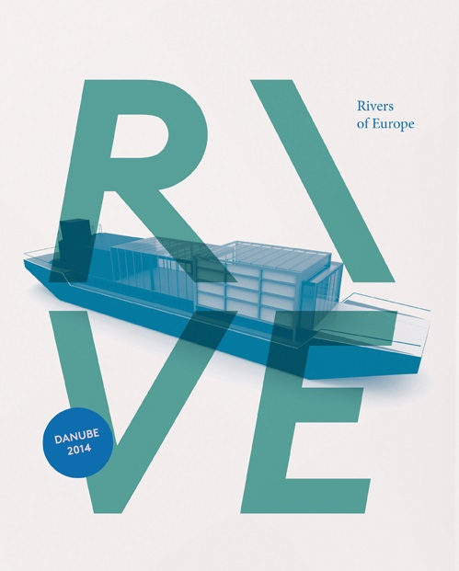

Rivers of Europe (RIVE)
is an intercultural initiative, developing a sense of European identity, based on common values, history and culture in a new regional concept. We implement water as an artistic element to connect the cultures among the riversides of the main cross-border rivers in Europe to represent trans-national mobility.

The Concept
Rhine, Elbe, Danube and Oder are the most important and determinative rivers of Europe. These rivers are an opportunity to reach the whole continent through water. They are links between nations, regions, and according to the well-known thesis, water beholds a common memory, a link between past and future.
The main aim of RIVE is bringing people together from local communities across Europe to share and exchange experiences and values on a cultural level, to learn from heritage and build the future through intercultural dialogue. Through RIVE the common and diverse European culture, indentity, history and languages can flow again.

The project coordinator is the Hungary-based international team of Pro Progressione, creating a strong co-work between arts field with multi-cultural team creating a conceptual answer on the question of technical and cultural involvement of water elements, high level of cultural quality, audience-friendly, easily understanable.

The creating process ends up in a 57 DAYS crusising along the DANUBE from the BLACK FOREST to the BLACK SEA on a 1884 KM length.
During this time RIVE is presenting 52 PERFORMANCES in 44 CITIES involving 25 ARTISTS in 11 COUNTRIES using one ship and one bus as part of a Rolling Tour.

Artistic Concept
RIVE builds divers connections between countries, artists and the local audience using Rhine, Elbe, Danube and Oder, as a transfer for culture. All partner organizations delegate artists to each discipline. The project involves four disciplines under international supervision:
- MUSIC, artistic leader: Kamil Sobiczewski (Poland)
- VISUAL ARTS, artistic leader: Max Biskup (Austria)
- DANCE , artistic leader: Jivko Jelazkov (Bulgaria)
- DESIGN , artistic leader: Gergely Kukucska (Hungary)
- PROJECT COORDINATION: Barna Pertányi (Hungary)
- ARTISTIC COORDINATION: Ilona Paszthy (Germany)

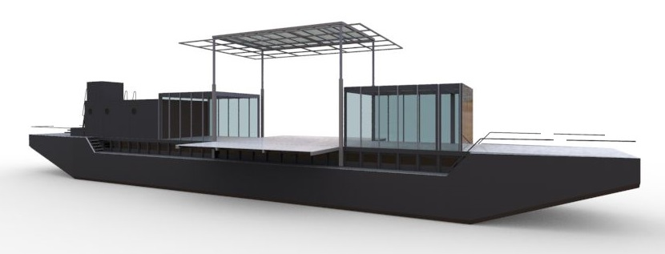

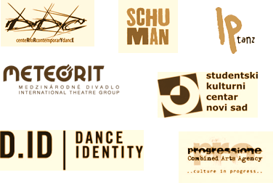
The Partners
The Program
Artists from the whole Danube Region and beyond have collaborated within the RIVE project for the past year and created a program that presents:
CONTEMPORARY DANCE STREET ART
VISUAL ART ARCHITECTURE
MUSIC APPLIED DESIGN
Our activities include an exhibition, performances, open workshops, discussions and an ongoing research project that explores cultural knowledge along the Danube.

To invlove a wider audience, the ship will host a huge variety on daytime programmes:
INTERACTIVE WORKSHOPS
VISUAL SHOWS
EXHIBITIONS
GASTRONOMICAL EVENTS
The ship itself is going to be a visual attraction, and will be presenting PERFORMANCES. Besides being a performing sight, we are going to open a unique Danube GALLERY sharing artistic values from the Danube's region. At night the venue converts into a CULTURAL CONTACTPOINT with music arrangements, a BAR for get togethers and interaction.
Follow-up
The tour will continue with a ROLLING TOUR to bring the concept to the mainland in Poland and Germany. This journey involves the cities Warsaw to Frankfurt am Oder, Berlin, Köln and Stuttgart. Here we plan another 6 performances, so all together we reach an audience up to 12.500 visitors.

Creation Part
First part of the creation is held geographically separated (Germany, Hungary, Poland, Bulgaria), but parallel in time. Each discipline is working on the performance following the accepted guides, and using the internet there is a continuous connection and the way to share work in progress outputs. Ilona Pászthy, artistic coordinator visits all the creations to help and guide their work. Different disciplines are responsible for different part:
- music– ethno music of the participant countries creating
- design–using the symbols of rivers creating design for the performance and ship
- visual–using the water and for projection also on the surface of water or water fog
- dance–involving performing art

The output of the disciplines will be harmonized during a two week common creation time in Novi Sad. The river-side rehearsal is the time to put together the different parts, make possible modifications. The disciplines will react to each other as artists are able to finish the performance. At the end of the process arrives the ship, as scene and venue for further performances.
The last two weeks of the rehearsal period is made on board of the ship, the final scene. It is the time to make useful modifications for the specific circumstances. It is also the time to make the modifications on the body of the ship, like fine art installations, video projection, set ups etc. At the end of the process, the ship starts the trip to the launch destination in Regensburg. During the 57 day long trip, the artistic program is under continuously development.

Program of Rive
GERMANY – 16-23 August 2014
6 perfomances in Regensburg, Straubing, Passau

AUSTRIA – 25 August – 1 September 2014
6 perfomances in Linz, Melk, Krems, Vienna

SLOVAKIA – 2-15 September 2014
6 perfomances in Bratislava, Dunajska Streda, Komarno, Sturovo

HUNGARY – 8-23 September 2014
12 performances: Győr, Komárom, Esztergom, Visegrád, Budapest, Dunaújváros, Baja, Mohács

SERBIA – 24 September – 1 October 2014
6 perfomances in: Sombor, Novi Sad, Belgrade, Smederovo

CROATIA – 25-26 September 2014
one performance in Vukovar

BULGARIA/ROMANIA – 3-10 October 2014
seven performances in Vidin/Califat, Kozloduy, Szvistov/Zimincea, Ruse/Giurgiu
ROLLING TOUR PROGRAM
POLAND – 12-17 October 2014
3 occasions in Warsaw, Poznan, Slubice/Frankfurt an der Oder

GERMANY – 18-22 October 2014
3 ocassions Berlin, Cologne, Stuttgart

CLOSING CONFERENCE
The program will be closed with a conference in Vienna, focusing on the possibilities to involve rivers in intercultural dialogues, as well as the possible role of culture in the new established Riverside and other European strategies. This closing ceremony will invite all partners, representatives of cultural institutions, representatives of cultural projects along the Danube, Rhine, Oder, Elba, and will give an opportunity to all involved partners to find out possible future events like RIVE, using the shared knowledge and all the experience of this program.

